**TECHNICAL REPORT ON BROOKLYN HIGH SCHOOL DIGITAL RESULT MANAGEMENT SOLUTION (PROJECT 2).**

**Prepared by:**

* **Itam Chinecherem Kalu**
* **Nuamenia Esther Neebee**
* **Awwal Onimisi Abdulmumin**
* **Ejiroghene Onokpite**

**(Team A)**

**Date: 29th July 2025.**

**INTRODUCTION**

**Purpose:**

To build a digital result management system to automate and simplify student result handling, ensuring accuracy and easy access.

It reduces errors, saves time, promotes transparency, and aids administrative works.

**Methodology:**

This sample data, provided by Brooklyn High School, is comprehensive and has been supplied to support the development of a digital solution for managing student results.

Analytical Tools used in the Project include; **EXCEL, SQL, DAX** and **PowerBI**.

**EXCEL**

Below is assessment report provided by Brooklyn High



Using the assessment report provided, we used power query in Excel to append and consolidate multiple files into a single excel document.



**MySQL**

* . Create a database
* . Create a table for student list and student profile

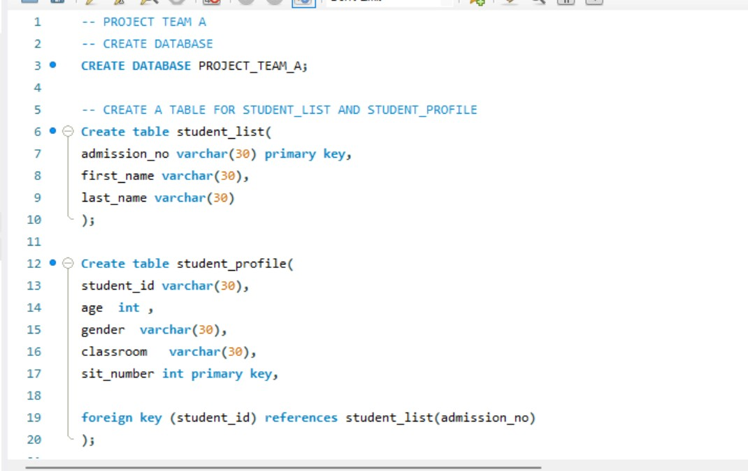

* **Join**

Join both student list & student profile (create a student demographic table)

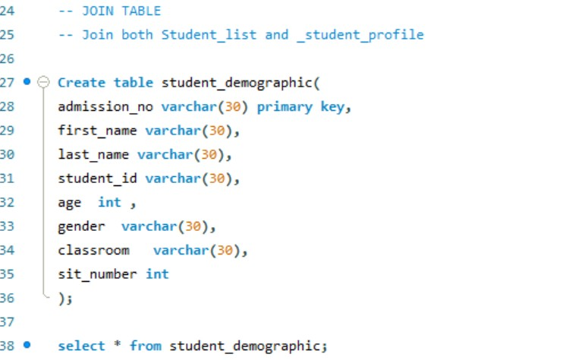

* **Unjoin**

We unjoin the data to separate the student list and student profile in the student demographic dataset.

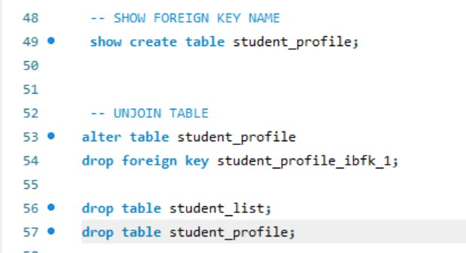

* Create table for courses and Results
* Insert into tables using implicit method

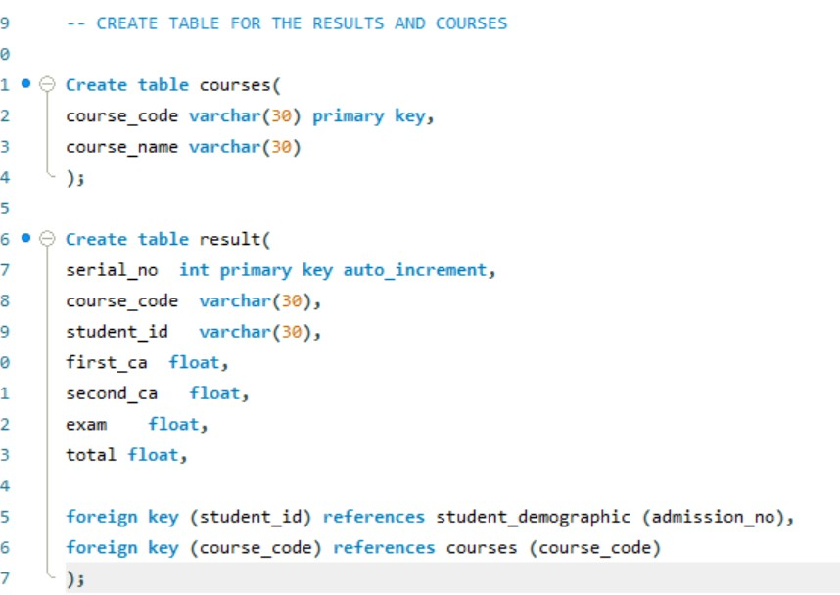

* **Modeling:** Model student demographic, results and courses.

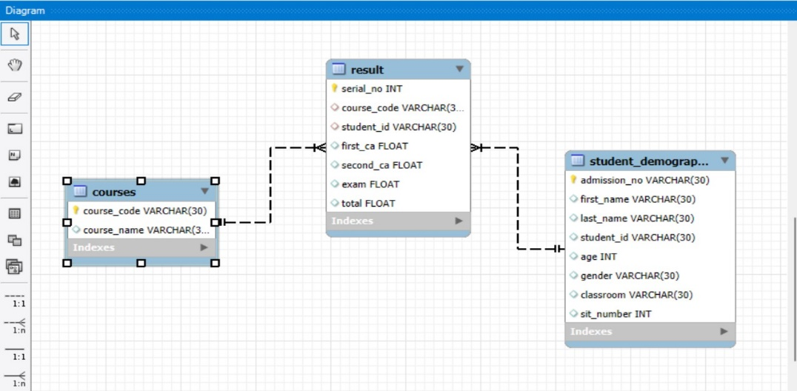

**DAX**

* To join first_name and last_name into full name



**POWERBi**

* Import data from MySQL into Powerbi

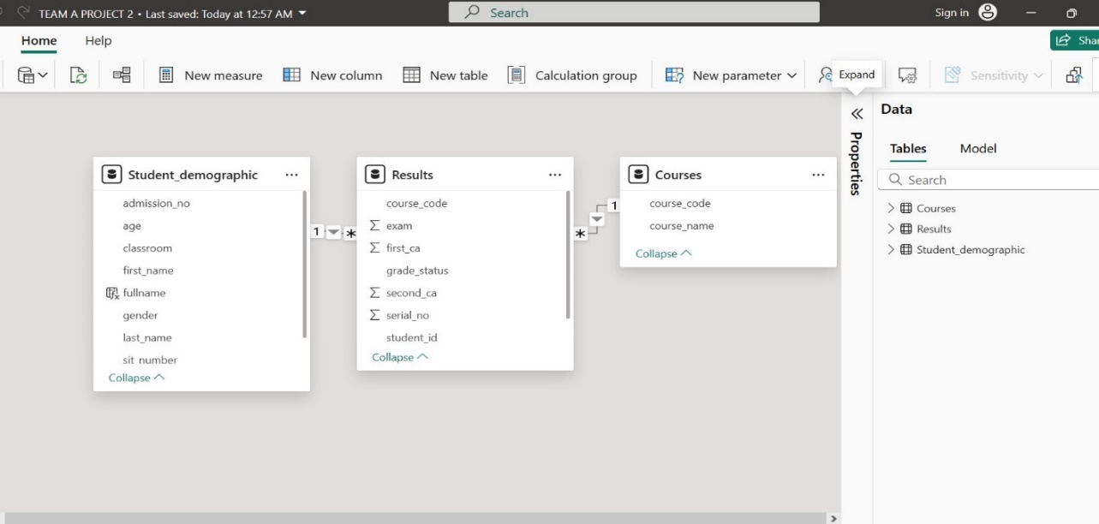

**Power Query**

* Used power query to transform data, add custom column (grade status) and set condition (if [total] > 80 then “pass” else “fail”)

**Build an interactive visualization.**

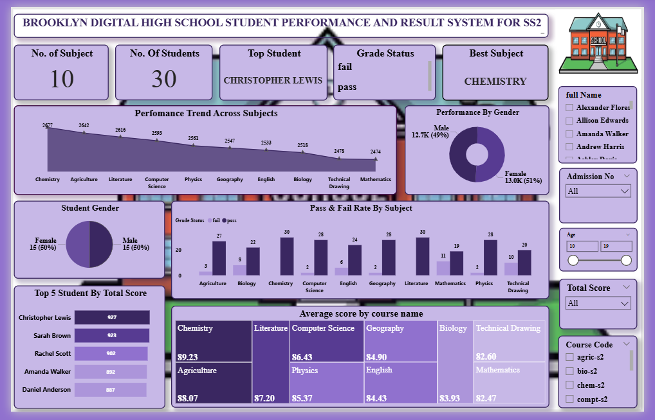

This PowerBi dashboard delivers comprehensive insights into students’ academic performance by highlighting Performance trend across subjects, Performance by gender, Student gender, Pass & fail rate by subject, Top 5 students, Average score by course name, and features interactive KPIs and slicers to allow deeper exploration and analysis of the data.

1. **Performance Trends across subject**

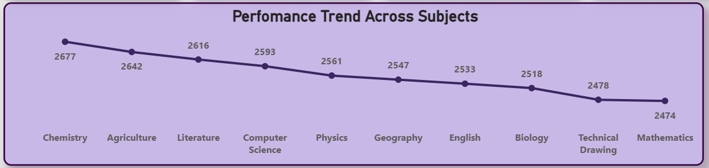

* **Chemistry** shows the highest performance with total score of 2677
* Agriculture: 2642
* Literature: 2616
* Computer Science: 2593
* Physics: 2561
* Geography: 2547
* English: 2533
* Biology: 2518
* Technical Drawing: 2478
* Mathematics: 2474

**Insight:** Chemistrytop in total score, but all subject demonstrates strong and balanced performance overall.

**2. Performance by Gender**

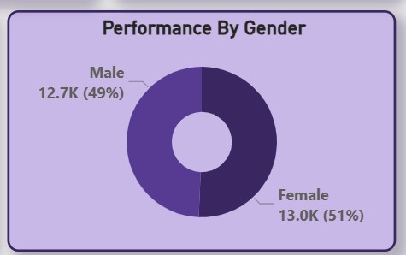

Female leading by 51% and Male by 49%.

**Insight:** With Female at 51% and Male at 49%, the data reflects a slight female dominance in student performance.

**3. Student Gender**

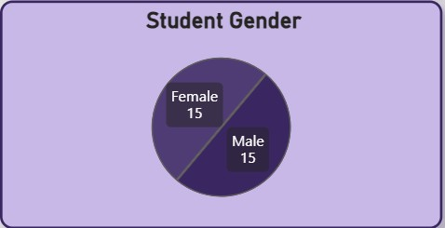

* Female: 15 Students
* Male: 15 students

**Insight:** Student population is evenly distributed by gender, with 15 female students and 15 male students, indicating a balanced gender distribution.

**4. Pass & Fail Rate by Subjects**

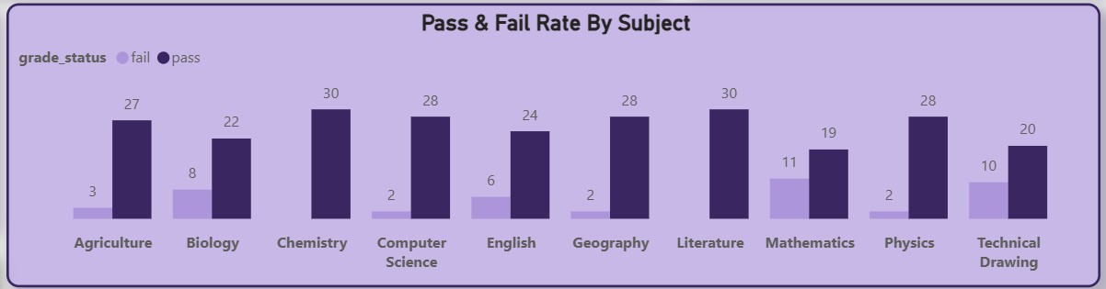

**Insight:** All Subject shows a high pass rate and low fail rate. To improve provide additional support to student.

**5. Top 5 Students**

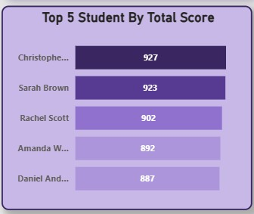

* **Christopher Lewis** leading with total score of **927** and **Sarah Brown** very closely with total score of **923**

**Followed by:**

* Rachel Scott – 902
* Amanda Walker – 892
* Daniel Anderson – 887

**Insight:** This shows tight competition at the top, highlighting strong academic performance among leading students.

**6. Average Score by course name**

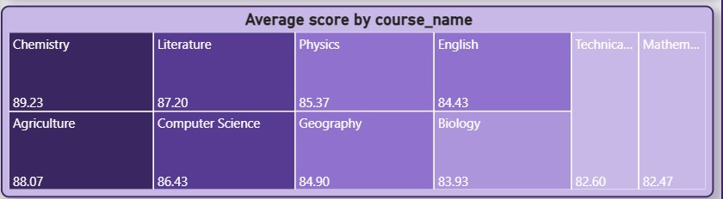

* **Chemistry** leads with the highest average score of **89.23**
* Follow by **Agriculture**, **Literature**, **Computer science** & **Physics** all above **85.00**
* **Mathematics** with the least average score of **82.47**

**Insight:** although Chemistry leads, other subjects also perform well, continued support is essential to address student needs across all area.

**OVERALL SUMMARY**

* **Total student:** There is a total of 30 students.
* **Total course:** Agriculture, Biology, Chemistry, Computer science, Geography, Literature, English, Mathematics, Physics and Technical drawing **(10).**
* **Top subject:** All 30-student passed **Chemistry.**
* All student is performing well across all subject.

**RECOMMENDATION**

* Offer extra support and practice for students struggling in certain subjects to boost their performance through tutoring, practice and regular feedback.
* Biology and Technical Drawing need immediate curriculum review and support systems and promote the methods used in Chemistry and Geography for broader academic success.
* Since majority of students **passed**, with only a small portion **failing**, Investigation should be carried out to ascertain the reasons behind the failures and provide extra support (e.g., remedial classes or tutoring) to struggling students.

**CONCLUSION**

Brooklyn Digital High School shows strong overall performance, with Chemistry and Geography leading in scores and Christopher Lewis as the top student. While most students passed, subjects like Biology, Mathematics, and Technical Drawing need improvement due to higher failure rates. Gender performance is balanced, though females slightly outperform males. Top students can be used to mentor peers. Focused support, improved teaching in weak subjects, and peer-led initiatives are key to boosting overall academic success.